**Serologic Response to Vaccine for COVID-19 in Patients with Hematologic Malignancy**

**Principal Investigator**: C. W. Phua

**Co-investigators**: I. Chin-Yee, B. Hedley, V. Bhayana, S. Lam, S. Li, J. Delport, M. Knauer, M. Haeryfar, S. Shalhoub

## Background

Several vaccines for COVID-19 disease caused by the severe acute respiratory syndrome coronavirus 2 (SARS-CoV-2) are currently approved, and widespread vaccination of the Canadian population is anticipated over the ensuing year. The record time for vaccine development and urgency which these were brought to market, some which use novel mRNA technology to produce these vaccines requires ongoing vigilance and monitoring. While studies are emerging that involve immunity in the healthy population, the clinical efficacy and response to these vaccines in patients with underlying hematologic malignancies, who are at high risk of COVID-19 due to their immunocompromised state and treatments, are uncertain. Patients who are treated with Rituximab, an anti-CD20 monoclonal antibody that causes rapid and prolonged B-cell depletion, are of a particular concern. In previous studies, rituximab has shown to impair vaccine specific immune responses mostly through blunting antibody production against influenza and pneumovax vaccines. Some reports have highlighted a variable cellular response as well in rituximab treated patients.

Based on previous studies demonstrating lower efficacy of some vaccines in immunocompromised patients, mostly derived by a lower immunogenic response to the vaccine compared to the general population, it is anticipated that COVID-19 vaccines may not bear the same efficacy in patients with hematologic malignancies. We propose a comprehensive serologic study to characterize the humoral (antibody) and cellular immune responses in haematology cancer patients who are immunized with the COVID-19 vaccination in the next 12 months to explore unanswered questions regarding vaccination of immunocompromised population. This study will also support validation of previous study that developed a serologic assay for COVID-19 antibodies, termed the agglutination assay on a larger population. As a sub study, we will also examine immune responses of vaccine in patients with hematologic malignancy diagnosis treated with rituximab compared to those with similar diagnoses without rituximab.

## Study Objectives

**Primary**

1. To evaluate the overall seroconversion to the COVID-19 vaccination in patients with hematologic malignancies. The serologic response after each vaccine dose will also be evaluated using the established Elisa antibody testing.

**Secondary**

1. To explore the variables that may affect antibody response such as type of hematologic malignancy, treatment received in proximity to vaccination, innate level of immunity pre-vaccination, and proximity to other vaccines.

2. To evaluate variables to vaccine response based on hematologic diagnosis and treatment exposure

3. To assess the durability of post-vaccination response

4. To determine the sensitivity and specificity to a recently developed latex agglutination assay

5. To determine the cellular immune responses to COVID 19 vaccine in patients treated/recently exposed to Rituximab

## Study design

Frozen samples for laboratory tests validation intended for discard will be diverted for potential testing to determine baseline incidence of COVID-19 seroconversion prior to vaccination. All patients with hematologic malignancies at London Regional Cancer Program (LRCP) intending to be or have been vaccinated will be invited to participate in the study. After an informed consent, participants will complete a short questionnaire to identify the dates of vaccine administration, the type of vaccine received/to be given, and if their anti-cancer treatment have been altered by their oncologist to facilitate receipt of COVID-19 vaccine. The questionnaire will also ask if they have received Rituximab within 6 months of their first dose of COVID-19 vaccination. A chart review will subsequently be completed to retrospectively identify age, sex, diagnosis, and treatment related to hematology malignancy, comorbidities, performance status, and pertinent lab test results. We will test eligible patients’ blood samples from their routine blood work as part of their LRCP clinic follow-up to determine vaccine responses at the following time points: before vaccination, after 2 weeks (up to 6 weeks but before the second dose) of the first dose, after 2 weeks (up to 6 weeks) of the second dose, at 3(±1) months, 6(±1), and/or 12(±1) months from the second dose of vaccine. The flexibility in the study timepoint window is to minimize additional visits to the LRCP clinic. The 6(±1), and/or 12(±1) months lab draw will only be completed if antibody response is detected in the 3(±1) months lab draw. If the period between the first and second doses is greater than 9 weeks, vaccine response within 4 weeks of second dose will also be determined. If their intended follow-up routine bloodwork does not fall within the windows as listed above, we may invite patients for an unscheduled visit for an additional lab draw of 5 mL.

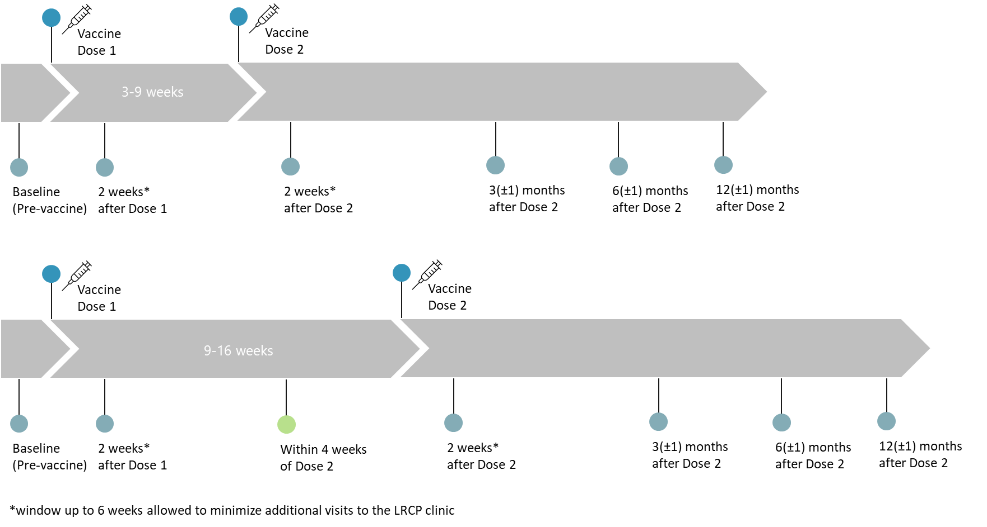

**Figure 1: Main study sampling points for humoral testing**

In the event the patients have received one or both doses of COVID-19 vaccine at the time of enrolment, and we do not have the baseline (pre-vaccine) and/or sample after the first dose, we will invite them to the study as long as a sample 2 (up to 6) weeks after the second dose can be and captured.

At the study time points 3(±1) months, 6(±1), and/or 12(±1) months from the second dose of vaccine, the participants will be asked to complete a questionnaire on whether they have contracted COVID-19 and if they have been in contact with a COVID-19 positive person.

For the sub study, we will invite patients who have received rituximab within the past 6 months to participate. We will recruit 20 patients where we will draw 10-15 mL of anticoagulated whole blood to isolate PBMCs (peripheral blood mononuclear cells) at the following time points: before the COVID-19 vaccine, 2 weeks (up to 6 weeks but before the second dose) after first dose, 2 weeks (up to 6 weeks) after the second dose, and 6 months after the second dose. We will also enroll 10 patients receiving similar types of chemotherapy but not on rituximab as a control group for the sub study. We will also draw 10-15 mL of anticoagulated whole blood from the 10 control patients.

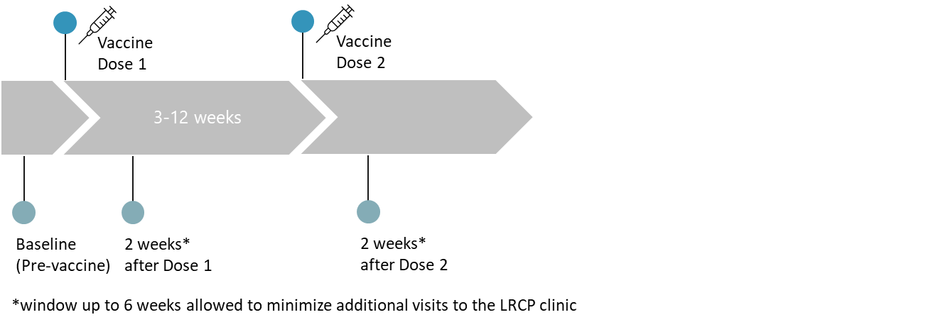

**Figure 2: Sub study sampling points for T-cell testing**

## Study Event Flowchart

|  |  |  |  |  |  |  |  |
| --- | --- | --- | --- | --- | --- | --- | --- |
| **Time Points** | **1** | **2** | **3** | **4** | **5** | **6** | **7** |
|  | Enrolment | 2-3 (up to 6) weeks after 1st dose of COVID-19 vaccine1 | Within 4 weeks of 2nd dose of COVID-19 vaccine2 | 2-3 weeks (up to 6) after 2nd dose of COVID-19 vaccine | 3(±1) months from 2nd dose of COVID-19 vaccine1 | 6(±1) months from 2nd dose of COVID-19 vaccine1,3 | 12(±1) months from 2nd dose of COVID-19 vaccine1,3 |
| Informed consent | x |  |  |  |  |  |  |
| Eligibility determination | x |  |  |  |  |  |  |
| Chart review | x | x | x | x | x | x | x |
| Enrolment questionnaire | x |  |  |  |  |  |  |
| Study questionnaire |  |  |  |  | x | x | x |
| Humoral testing for main study | x | x | x | x | x | x | x |
| T-cell testing for sub study | x | x |  | x |  | x |  |

1 For vaccines with 1 intended dose, this will be performed after receiving first/final dose of vaccine

2 Only the participants who will be receiving the second dose 9+ weeks after the first dose

3 Only completed if antibody response is detected in the 3(±1) months lab draw

## Study Methods

**Inclusion Criteria:**

1. Adults ≥ 18 years

2. Patients being seen at the LRCP with a hematological malignancy

3. Ability to provide signed and dated informed consent

**Exclusion Criteria:**

1. Individual unwilling to provide informed consent

2. Individual who chooses not to receive COVID-19 vaccine

**Serologic Testing:**

Two antibody testing will be conducted. The first will utilize Health Canada approved Roche Elecsys Anti‑SARS‑CoV‑2 immunoassay, and newly developed a latex agglutination method. The serologic test developed will be modified to detect the Nucleocapsid and Spike proteins, including the major epitopes within the spike protein. Using this assay, positivity for both N and S antigens would identify natural infected whilst positivity for only S would suggest vaccine acquired immunity**.** Epitope-based antibody testing wouldreveal the efficacy of the S antibodies to epitopes altered in the variants discovered in the UK, African and Brazil. Some of these variants have already been detected in Canada.

**T cell response Sub study**:

For the sub study, peripheral blood will be obtained from consenting patients and controls via venipuncture by a certified phlebotomist, placed in collection tubes containing an anticoagulant (e.g., heparin or EDTA) to prevent clotting, and immediately transferred to the Haeryfar Laboratory (located at SDRI 234) for further processing. PBMCs will be isolated through density gradient centrifugation, aliquoted and stored in a liquid nitrogen tank until use. Diluted plasma that can be obtained will be aliquoted and stored at -80 °C until use. Cellular immune response will be determined by exposing PBMCs to a pool of SARS-CoV-2 derived peptides and measuring IFNgamma using ELISPOT assays. This will enumerate Ag-specific T-cells collectively.

## Anticipated Results

1. Valuable information on the dynamics of antibody development to the COVID-19 vaccine, including the time for peak antibody production and duration in patients with hematologic malignancies.

2. Data linking antibody response to sex, age, underlying hematologic condition including therapies received for their hematologic conditions.

3. The simultaneous measurement for nucleocapsid antibodies will help us assess the population penetrance of the pandemic and study the effect of previous virus exposure to the efficacy of the vaccine by comparing the strength of spike antibody response between individuals that are negative (no prior infection) or positive for anti-nucleocapsid antibodies.

4. Validation of a POC antibody test developed in London by us that are based on antibody-dependent agglutination of latex particles.

5. Provide valuable information on the effectiveness of the spike mRNA-targeted vaccine to SARS-CoV-2 variants. This data will help guide the design of future vaccine formulations against these variants.

6. Comparison of cellular immune responses to COVID-19 vaccine in patients with hematologic malignancy diagnosis treated with rituximab with similar diagnoses and chemotherapy without rituximab.